INDONESIA DIASPORA NETWORK FRANCE

presents

WOMEN IN BALI by BRUNA ROTUNNO

Sunday May 14th, from 3pm to 6pm, Bruna Rotunno will be in Paris, at the restaurant Djakarta-Bali, for a signing session of her book WOMEN IN BALI. The presentation will be followed in the year by an exhibition featuring the book’s images.

- Bruna Rotunno will present her book at 3:30 pm

WOMEN IN BALI

WOMEN IN BALI is a book, a photography project, between art and reportage, a journey of images in the heart of Bali and a tribute to the energy of all the women who live there. Bruna Rotunno tells the female universe and the creative power of nature, the island where the water is still revered as a sacred source of life. In the artist’s shots, women move with grace and strength: they dance, work, live and smile between rocky appearances and landscapes in motion, in the expanded dimensions of spirituality.

The book WOMEN IN BALI collects all this material, more than 150 photographs, accompanied by texts by Anita Lococo, American resident for 35 years on the island, and Cok Sawitri, the most famous Balinese writer.

The book WOMEN IN BALI, published by Silvana Editoriale, is on sale in the best libraries in the world.
With the first 1000 copies of the book, a donation of 5% will be allocated to the association Smile of Bali, which provides assistance and free operations to children with severe physical deformities.

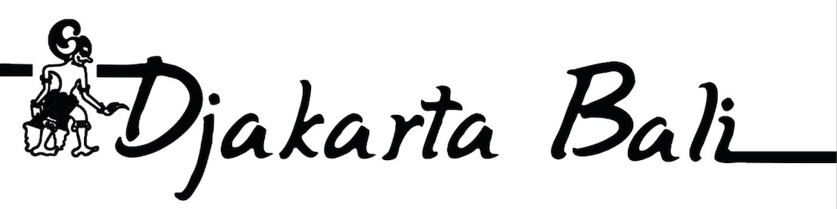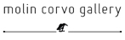
Address:
Djakarta-Bali
9 Rue Vauvilliers – 75001 Paris
Tèl.: +33 1 45 08 83 11
www.djakarta-bali.com

www.indonesiandiasporanetwork.com/fr
For more information:
info@molin-corvo.com
+33 6 62 01 39 59
www.molin-corvo.com

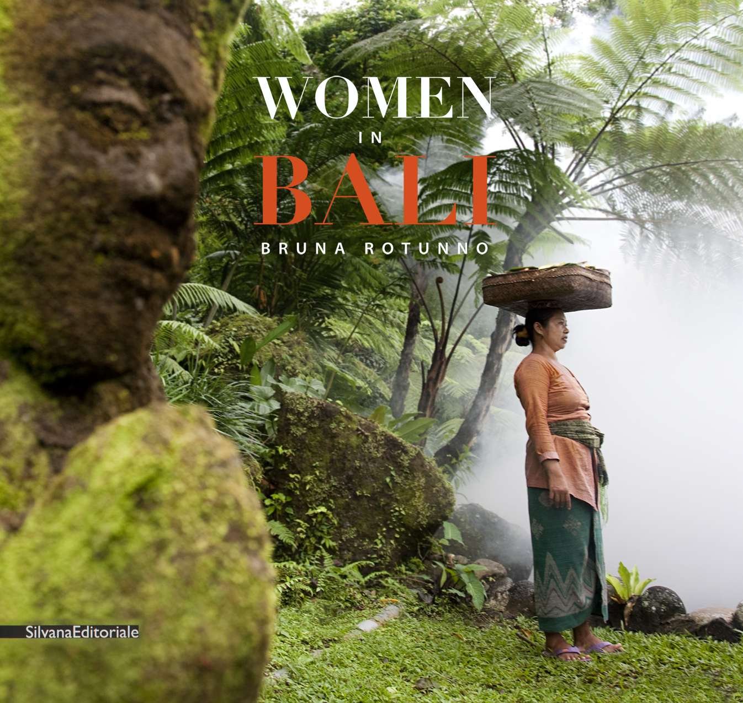
Technical details
WOMEN IN BALI
- Hard top luxury cover
- size 27x28,5cm, pag.130
- Languages: English, France, Italian
- First Edition: 2000 copies
- Publisher: Silvana Editoreriale
- Distributed worldwide

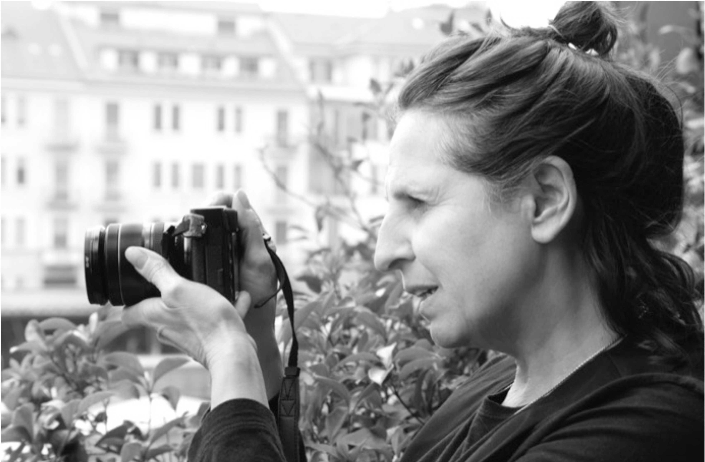
Bruna Rotunno

Bruna Rotunno lives between Europe and Asia. After graduating in psychology, she started to be interested in photography, particularly in the portraits, fashion images and video art. She collaborates with several magazines, including Vogue. Her art, including portraits and landscapes, transcends genres and alternates pictorial sensibility to the immediacy of reportage, preserving the integrity of the subject photographed. Her vision is developed on Stories Telling of reality, propulsive element of investigation and research, captured in deeply emotional images. Her work has been exhibited in numerous galleries in Europe. She participated to the Venice Biennale, she has exhibited a solo show at the Milan Triennale and she has already published five books.

